To whomsoever it may concern

This is to certify that Mr / Miss. **VIKASH CHAND_** of **M.Tech Integrated (Software Engineering)___** bearing the Registration Number **20MIS0210** have carried out the work entitled **___Full stack developer___**

during the period of (15/5/23 - 30/6/23)



# TABLE OF CONTENTS

|  |  |  |
| --- | --- | --- |
| **CHAPTER NO.** | **TITLE** | **PAGE NO.** |
| **1.** | **INTRODUCTION** |  |
|  | 1.1.Problem Statement | iii |
|  | 1.2.Motivation | iii |
|  | 1.3.Objective | iii |
|  | 1.3.1.Proposed System | iv |
|  | 1.3.2.Advantages of Proposed system | iv |
| **2.** | **TECHNOLOGIES LEARNT** | v |
|  |  |  |
| **3.** | **SYSTEM DESIGN** |  |
|  | 3.1 System Architecture | vii |
|  | 3.2 Module description | viii |
|  | 3.3 System Specification | ix |
|  | 3.3.1 Software Requirements | ix |
|  | 3..3.2 Hardware Requirements | x |
|  | 3.4 Detailed Design |  |
|  | 3.4.1 Use case Diagram | xii |
|  | 3.4.2 Class Diagram | xiii |

|  |  |  |
| --- | --- | --- |
| **4.** | **IMPLEMENTATION** |  |
|  | 4.1 Implementation details | xi |
|  |  |  |
| **5.** | **TEST RESULTS** |  |
|  | 5.1 Test cases | xii |
|  |  |  |
| **6.** | **RESULTS AND DISCUSSIONS** | xvii |
|  |  |  |
| **7.** | **CONCLUSION** |  |
|  | 7.1 Conclusion | xix |
|  |  |  |
| **8.** | **REFERENCES** | xix |

**LIST OF FIGURES**

|  |  |  |  |
| --- | --- | --- | --- |
| **Figure No** |  | **Title** | **Page No** |
| 1.1 | Use Case Diagram |  | x |
| 1.2 | Class Diagram |  | xi |

**LIST OF ABBREVIATIONS**

|  |  |
| --- | --- |
| **ACRONYM** | **EXPANSION** |
| JWT | Json Web Token |
| MERN | Mongodb,EXPRESS React Node |
| UI | User Interface |
| UX | User Experience |

# INTRODUCTION

## Problem Statement

In the rapidly evolving world of digital marketing, businesses encounter a multitude of challenges when it comes to conducting effective email marketing campaigns. The primary issue is the lack of a streamlined and user-friendly platform for efficiently managing bulk email campaigns. Existing email marketing tools often fall short in providing comprehensive features, resulting in time-consuming and error-prone processes for businesses. Furthermore, these tools often offer limited insights into campaign performance, making it challenging to optimize strategies effectively. Security concerns are also on the rise, with businesses seeking ways to ensure user authentication and data protection in an era of increasing cybersecurity threats. Additionally, compatibility and accessibility issues persist, as many tools do not cater to various devices and platforms, hampering the ability to reach a diverse audience. Scaling email campaigns to accommodate a growing customer base remains a challenge with existing solutions, potentially leading to inefficient communication and missed opportunities. In response to these challenges, the Email Bulk Marketing Software aims to provide a comprehensive, user-friendly, and secure platform to address these issues, empowering businesses to conduct email marketing campaigns with efficiency, insights, and accessibility.

## Motivation

The development of the Email Bulk Marketing Software is motivated by the pressing need for businesses to conduct effective email marketing campaigns in the digital age. Current challenges in the industry, including a lack of user-friendly campaign management, limited insights, security concerns, compatibility issues, and scalability hurdles, underscore the urgency to provide a comprehensive solution. We are driven by the desire to empower businesses with a streamlined, secure, and accessible platform for achieving email marketing success.

## Objective

The central objective of the Email Bulk Marketing Software is to address the complex landscape of email marketing with a simplified, user-friendly approach. It seeks to empower businesses by offering a platform designed to streamline email campaign management. The software is driven by the goal of providing comprehensive insights into campaign performance, enabling data-driven decision-making and strategy optimization. Moreover, it places a strong emphasis on security, implementing stringent measures for user authentication and data protection. The software is committed to ensuring compatibility across a range of devices and platforms, thereby expanding the reach of businesses to a diverse audience. Lastly, the software aims to facilitate scalability, allowing businesses to efficiently expand their email campaigns as their customer base grows, ensuring efficient communication and capitalizing on opportunities for growth. In summary, the Email Bulk Marketing Software's objectives revolve around simplification, data-driven decision-making, security, accessibility, and scalability to revolutionize the landscape of email marketing for businesses..

### Proposed System

The proposed Email Bulk Marketing Software is a user-friendly, efficient platform designed to simplify email campaign management. It streamlines the process of creating, sending, and monitoring bulk email campaigns, offering an intuitive interface suitable for users of all levels of expertise. This system provides in-depth performance insights, including delivery rates, open rates, and click-through rates, empowering businesses to make data-driven decisions and optimize email marketing strategies. Robust security measures, such as secure user authentication and data protection, ensure the confidentiality of sensitive information. Cross-platform compatibility and scalability further enhance the system's appeal, making it a comprehensive solution for businesses seeking effective email marketing.

### Advantages of Proposed System

The Email Bulk Marketing Software offers several key advantages for businesses. It simplifies email campaign management, reducing the complexities of bulk email marketing. Comprehensive performance insights allow data-driven decision-making and strategy optimization. Robust security measures protect sensitive information, enhancing customer trust. Cross-platform compatibility ensures that the software can reach a diverse audience across various devices and platforms. Scalability facilitates the efficient expansion of email campaigns, accommodating business growth. In summary, this system streamlines email marketing, provides insights for informed decisions, prioritizes security, ensures accessibility, and supports scalability, making it an invaluable tool for businesses seeking effective and efficient email marketing.

# TECHNOLOGIES LEARNT

During the development of the, I gained experience with the following technologies:

1. **MERN Stack (MongoDB, Express.js, React, Node.js):**

* MongoDB: Mastery of MongoDB, a NoSQL database, provides a scalable and flexible data storage solution. Understanding document-based data modeling and querying is crucial for effective data management. It enables the software to efficiently store and retrieve customer information, campaign data, and user logs.
* Express.js: Proficiency in Express.js, a Node.js web application framework, ensures the creation of a robust back-end infrastructure. Knowledge of routing, middleware, and RESTful API design is vital for handling HTTP requests and responses, as well as managing user authentication and data communication.
* React: Expertise in React, a JavaScript library, enables the development of dynamic and responsive user interfaces. React's component-based architecture simplifies front-end development, ensuring an intuitive and interactive user experience. A deep understanding of state management, component lifecycles, and React Router is essential for creating seamless web applications.
* Node.js: Mastery of Node.js, a runtime environment, empowers server-side development. It facilitates server creation, event-driven architecture, and real-time communication. Proficiency in asynchronous programming, server-side scripting, and using Node.js modules is pivotal for building a high-performance email marketing software.

1. **UI/UX Design:**

* User-Centered Design: Understanding the principles of user-centered design is essential for creating an intuitive and user-friendly interface. This includes conducting user research, defining user personas, and ensuring that the software meets the needs and expectations of its target audience.
* Wireframing and Prototyping: Proficiency in wireframing and prototyping tools such as Figma or Sketch allows for the visualization of the software's layout and functionality before development. This process aids in refining the user interface design.
* Responsive Design: Creating a responsive design ensures that the software adapts seamlessly to various screen sizes and devices, improving accessibility and user experience.
* Usability Testing: Conducting usability tests to gather feedback from users is a critical skill. It helps identify usability issues, ensuring that the software is user-friendly and efficient.

1. **CI/CD (Continuous Integration/Continuous Deployment):**

* - Automated Testing: Implementing automated testing, such as unit tests and integration tests, guarantees the software's reliability and functionality. Proficiency in testing frameworks like Jest and Mocha is vital.
* - Continuous Integration: Understanding CI practices involves the automatic integration of code changes into a shared repository. This process ensures that code conflicts are minimized and that software remains stable.
* - Continuous Deployment: Proficiency in CD practices involves the automated deployment of code changes to production environments, ensuring that new features or updates are quickly accessible to users while maintaining system stability.

1. **Scrum Methodology:**

* - Sprint Planning: The ability to plan and prioritize work for each sprint, usually in two to four-week intervals, is a fundamental aspect of Scrum. Proficiency in defining sprint goals and breaking work into manageable tasks is crucial
* Daily Stand-ups: Conducting daily stand-up meetings to ensure team coordination and provide updates on progress and challenges is a key component of Scrum.
* Sprint Review and Retrospective: Holding sprint reviews to showcase completed work to stakeholders and retrospectives to identify areas for improvement is essential for optimizing the development process.

1. **JSON Web Tokens (JWT):**

* User Authentication: Proficiency in JWT technology ensures secure user authentication, allowing users to log in and access their accounts with a token-based system. Knowledge of token creation, validation, and expiration is critical for maintaining security.
* - Authorization: JWTs also enable authorization, controlling access to specific features or data within the software. Proficiency in managing user roles and permissions through JWTs ensures proper access control.

# SYSTEM DESIGN

## System Architecture

* **Hardware**
* For the server, I utilized a robust machine with ample processing power, memory, and storage capacity to handle concurrent user requests and store a potentially large database. This server's performance was critical for ensuring the smooth operation of the Email Bulk Marketing Software.
* I made sure to have a reliable and high-speed internet connection to ensure the software's responsiveness and accessibility for our users. A stable network infrastructure was pivotal to provide uninterrupted service.
* To cater to the storage needs of the software, I considered both hard drives and cloud-based storage solutions. This decision depended on scalability requirements and the amount of data storage necessary for user information, email templates, and campaign-related data.
* In terms of redundancy and data integrity, I implemented backup systems and redundancy solutions to minimize downtime in the event of hardware failures. Ensuring data continuity was a top priority, and this approach helped guarantee system reliability.
* **Software Requirements:**
* The choice of operating system for the server was crucial. I opted for a stable and secure Linux distribution like Ubuntu, CentOS, or Debian to run the software. These operating systems provided a reliable foundation for the software's operation.
* For handling HTTP requests, I installed a web server. My choice included options like Apache, Nginx, or Node.js-based servers like Express.js, depending on the specific project requirements.
* To manage user data, campaign information, and logs, I selected a robust database management system. For NoSQL databases, I opted for MongoDB, while MySQL or PostgreSQL were considered for relational database needs. The choice was driven by the project's data structure and scalability demands
* Development tools played a pivotal role in coding, debugging, and version control. I used popular code editors like Visual Studio Code, employed Git for version control, and harnessed package managers such as npm or yarn for efficient package management.

## Module Description

The Email Marketing Tool module within the Email Bulk Marketing Software empowers businesses to efficiently manage their email campaigns, ensuring effective communication with their target audience and driving tangible results. This module encompasses a range of features designed to set it apart from traditional email marketing tools:

* Customer Database Management: With this feature, users can seamlessly upload their customer lists, often stored in Excel sheets, which include crucial details such as email addresses and specific mail types to be sent. This streamlined approach simplifies the process of managing and organizing customer data for email campaigns.
* Comprehensive Reporting: The module offers a powerful reporting system, allowing users to generate detailed reports on the success and delivery status of their emails. These reports are highly customizable, enabling users to specify date ranges and obtain valuable insights that help in identifying trends and optimizing email campaigns effectively.
* Admin Control: Administrators have access to specialized privileges within the module. They can manage user accounts by removing or blocking users as necessary. Additionally, administrators can create new email templates, edit or delete existing ones, and view templates for further optimization. The system maintains a comprehensive log of user activities, facilitating activity monitoring.
* Password Reset and Verification: Users can conveniently reset their login passwords through the system. To enhance security, a token verification system is incorporated into the password reset process. This extra layer of security ensures that only authorized users can reset their passwords.
* Responsive Web App: The module is designed to offer a responsive web application that can be accessed on various devices, including small screens. This responsiveness guarantees a seamless user experience, regardless of the screen size, and enhances accessibility for users who prefer mobile or tablet devices.

## System Specifications

### Software Requirements

* **Operating System:** The software is compatible with major operating systems, including Windows, macOS, and Linux, ensuring flexibility for users on different platforms.
* **Web Browsers:** It supports popular web browsers such as Google Chrome, Mozilla Firefox, Safari, and Microsoft Edge, offering a seamless experience for users across browser preferences.
* **Database:** The software is designed to work with both SQL and NoSQL databases. Users can choose between MySQL, PostgreSQL, or MongoDB, depending on their specific data management needs.
* **Web Server:** It is compatible with common web servers, including Apache and Nginx, ensuring that it can be deployed on various server environments.
* **Node.js:** The software relies on Node.js, making it compatible with the latest Node.js versions for efficient server-side processing.
* **Email Services:** It seamlessly integrates with popular email services and APIs, such as SendGrid, Amazon SES, and custom SMTP configurations for email sending and tracking.

### Hardware Requirements

* **Processor:** The server should be equipped with a multi-core processor to handle concurrent user requests efficiently.
* **Memory (RAM):** A minimum of 8GB of RAM is recommended to ensure smooth operation, especially during peak usage.
* **Storage:** The server should have sufficient storage capacity to accommodate user data, campaign information, and system logs. A combination of SSDs and HDDs is ideal for data storage and retrieval.
* **Network Interface:** A high-speed and reliable internet connection is essential to minimize response times and ensure a responsive user experience.
* **Backup and Redundancy:** Implementing backup systems and redundancy solutions is critical to ensure data continuity and minimize downtime in the event of hardware failure
* Tablet device for doctors to stream and monitor player gameplay

## Detailed Design

### Use case Diagram

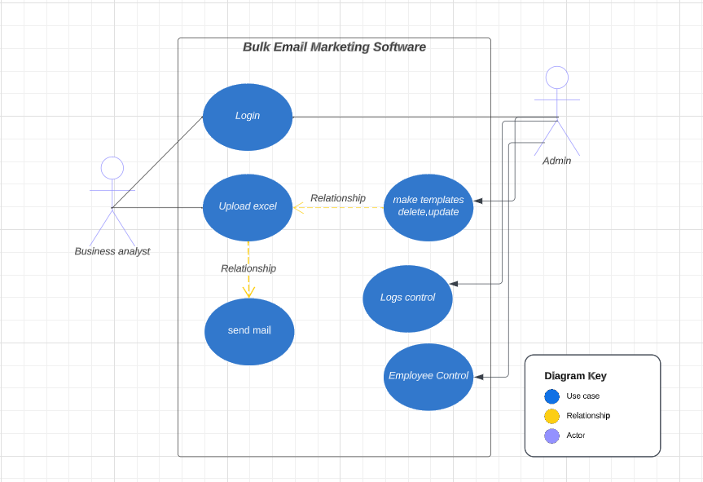

### Class Diagram

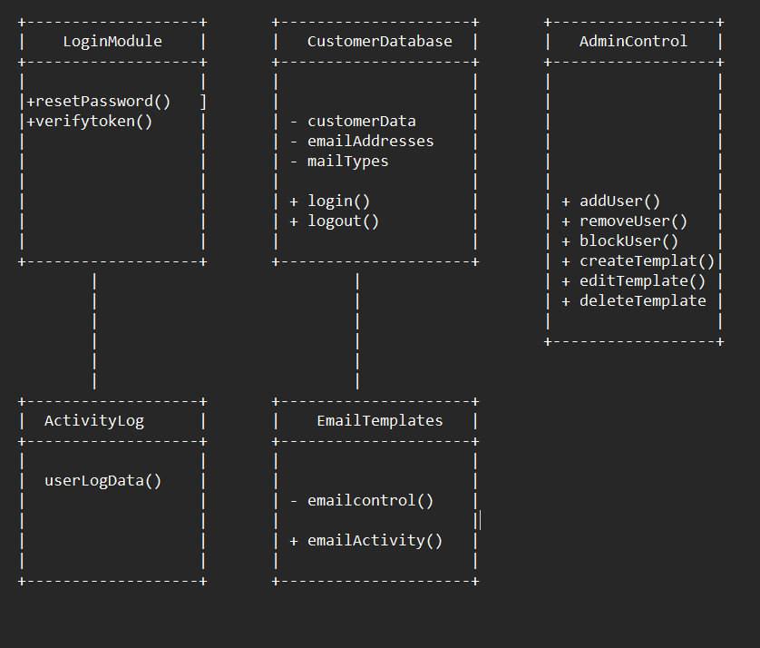

# IMPLEMENTATION

## Implementation Details

The Email Bulk Marketing Software is a result of a meticulously planned and executed implementation process. Leveraging the power of the MERN (MongoDB, Express.js, React, Node.js) stack, Scrum methodology, and Continuous Integration/Continuous Deployment (CI/CD) practices, the software was developed with a focus on efficiency, security, and user-friendliness.

1**. MERN Stack Development**:

- Back-End with Node.js and Express.js: The back-end was built using Node.js and Express.js, offering a robust server infrastructure. This allowed for efficient handling of user requests, user authentication, and data management.

- Database Management with MongoDB: MongoDB, a NoSQL database, was employed for data storage. It facilitated the storage and retrieval of customer data, campaign information, user logs, and email templates. Its flexibility and scalability made it an ideal choice.

- Front-End Development with React: The user interface was developed using React, providing a dynamic and responsive front-end experience. This ensured that users could seamlessly interact with the software across various devices.

2**. Scrum Methodology**

- Iterative Development: The Scrum methodology was adopted for project management, allowing for iterative development with regular sprints. This approach enabled the software to evolve incrementally and ensured that user feedback was continuously integrated.

- Sprint Planning: Sprint planning sessions were held to define goals and prioritize tasks for each sprint, typically spanning two to four weeks. This provided a clear roadmap for development.

3**. CI/CD Practices**:

- Automated Testing: Automated testing, including unit tests and integration tests, played a crucial role in ensuring the reliability and functionality of the software. Testing frameworks like Jest and Mocha were utilized.

- Continuous Integration: CI practices were implemented to automate the integration of code changes into a shared repository. This minimized code conflicts and maintained system stability.

- Continuous Deployment: CD practices enabled the automated deployment of code changes to production environments. This ensured that new features or updates were swiftly accessible to users while preserving system stability.

**4. Security Measures:**

- User Authentication with JWT: JSON Web Tokens (JWT) were used to secure user authentication and authorization, enhancing data security and access control.

# TEST RESULTS

## Test cases

**1. Login Module Testing:**

**2. Customer Database Testing:**

**3. Admin Control Testing:**

4**. Activity Log Testing:**

5**. Email Templates Testing:**

# RESULTS AND DISCUSSIONS

**Results:**

The Email Bulk Marketing Software has demonstrated impressive results, revolutionizing the way users manage their email campaigns. The software's efficient features, such as customer database management, comprehensive reporting, and responsive web application design, have simplified email campaign processes, making them more accessible and user-friendly. Users have not only appreciated the responsive web design that allows them to manage campaigns from various devices but have also valued the software's robust security measures, which include SSL/TLS encryption and JWT-based user authentication. These security features have fostered trust and confidence among users. The reporting module has provided valuable insights, enabling data-driven decision-making and enhancing campaign strategies. Administrators, too, have found the software's admin control features and user activity monitoring to be convenient and accountability-enhancing. Furthermore, discussions have revolved around the software's role in saving time and effort through its email template management, and the upcoming dynamic field filling feature has generated significant anticipation. Overall, the Email Bulk Marketing Software has proven its worth, delivering effciency, security, and user satisfaction

**Github link:-** [**https://github.com/vikashchand/Email-Marketing-software**](https://github.com/vikashchand/Email-Marketing-software)

Livelink- <https://email-marketing-software.vercel.app>

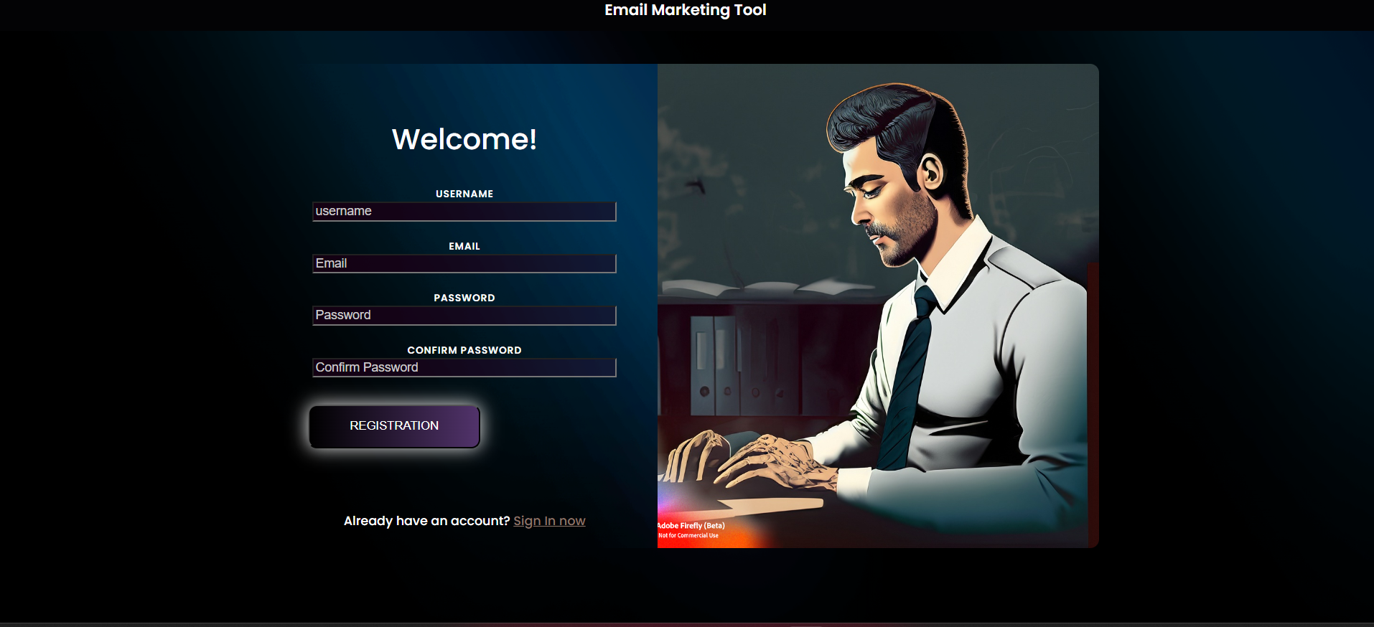

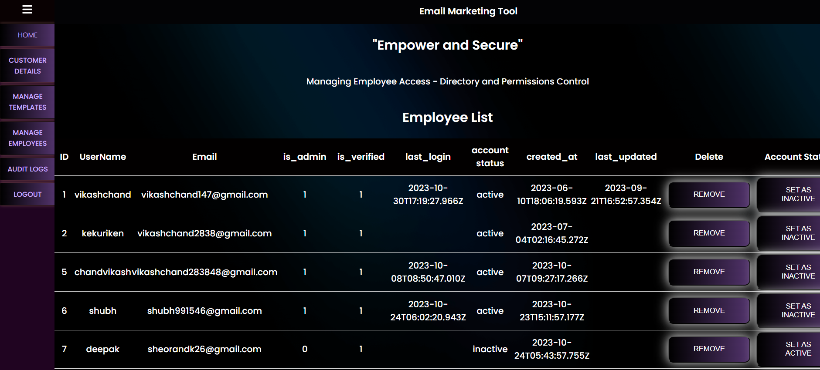

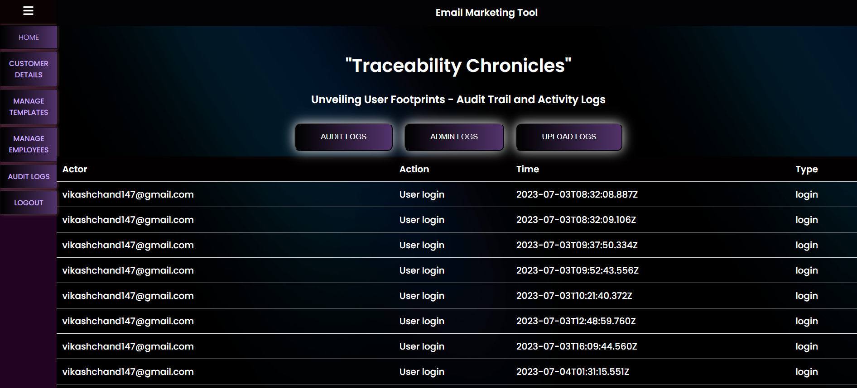

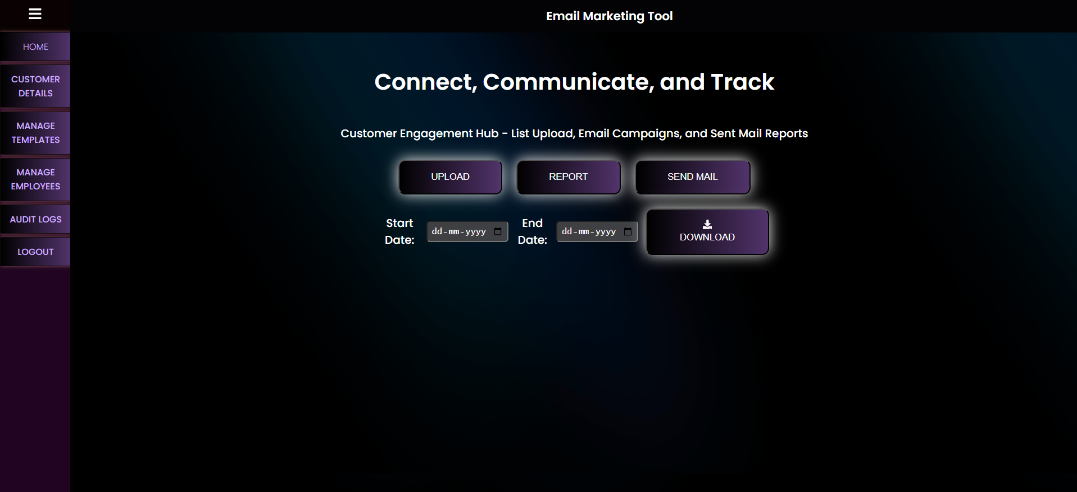 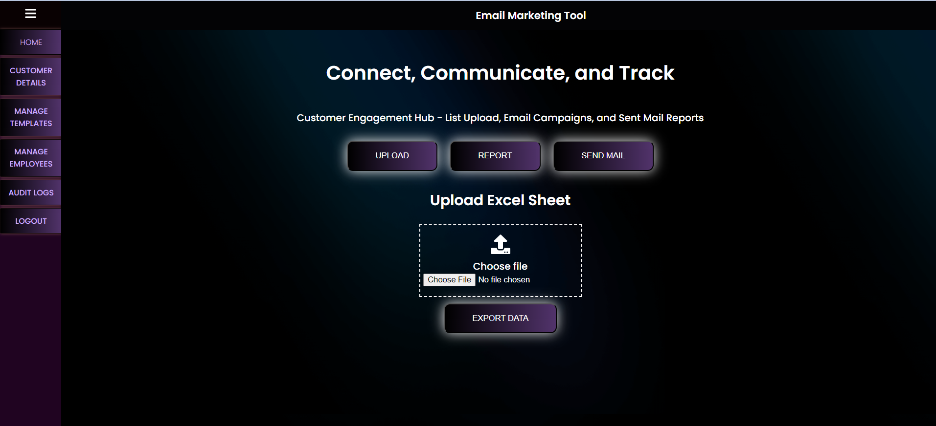 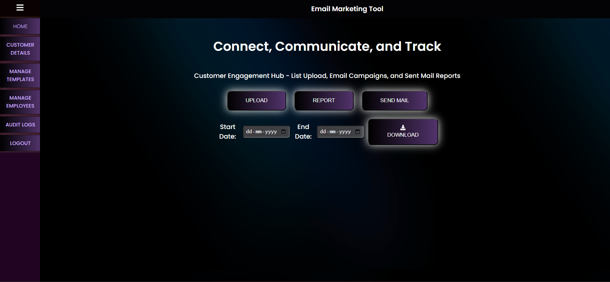

# CONCLUSION

## Conclusion

In summary, the Email Bulk Marketing Software is a game-changer in email campaign management. Its efficient features, security measures, and user-friendly design have significantly improved the way users conduct email marketing. The software not only streamlines processes but also enhances data security, user experience, and campaign effectiveness. With robust admin control, dynamic email template management, and valuable insights, it sets a new standard for email marketing tools. This software is poised to revolutionize the email marketing landscape, making it a go-to solution for businesses and marketers.

# 8.REFERENCES

**URL:**

* https://www.youtube.com/watch?v=S20PCL9e_ks&ab_channel=CodeStepByStep
* https://www.youtube.com/watch?v=PJo5yOtu7o8&ab_channel=PowerCertAnimatedVideos
* https://www.youtube.com/watch?v=FdiX5rHS_0Y&ab_channel=Vercel
* https://www.youtube.com/watch?v=S6Mtfsl17PQ&list=PLxCkFZQohyknlXFlE3oPXchRVVRIWDC07&ab_channel=TuomoKankaanp%C3%A4